Assignment Rachel Carson

Writing about the science of nature may take away from the meaning and aesthetics. Using Carson’s writings below and the information provided - write a five paragraph argumentative response to the following prompts (Please write using an argument style of format):

Would you agree or disagree that:

Rachel Carson’s science and nature writing style, is an effective literary strategy linking science with people’s emotions and beliefs about nature in an effort to change those beliefs?

Or

Is Rachel Carson’s “Fable for Tomorrow,” as she called it, setting the tone for the hodgepodge of science and junk science in the rest of the book. Nature was good; traditional agriculture was all right; modern pesticides were an unprecedented evil. It was a “Disneyfied” version of Eden.

Mosquitos, Why don't we just kill all of them with pesticides?
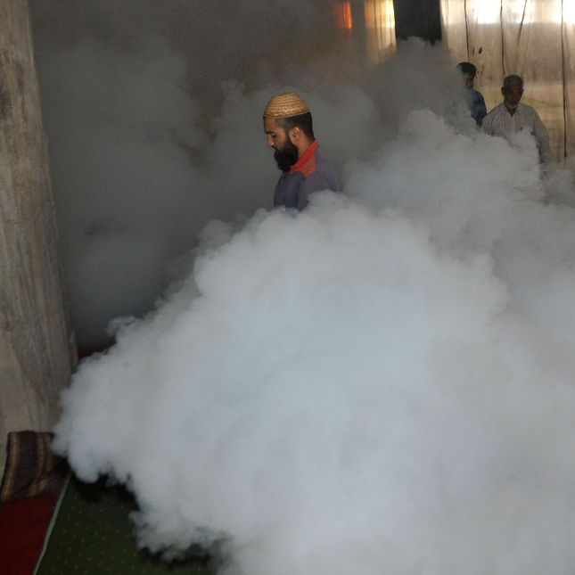
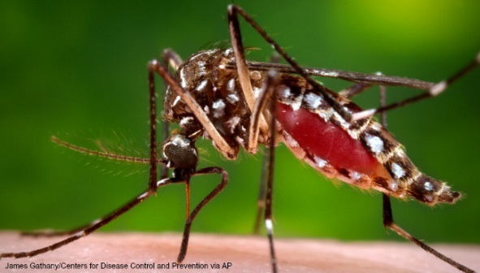

EEE
A pool of mosquitoes collected in Warren tested positive for West Nile virus, the Rhode Island Department of Health confirmed Thursday. It’s the first time the mosquito-borne illness has been detected in Rhode Island this year. There have been three previous findings of Eastern equine encephalitis (EEE). The pool which tested positive contained the species of mosquito that bite both birds and humans, health officials said. They said the other 105 traps set the same day tested negative for both West Nile and EEE.

Zika
A child was born in Rhode Island with the Zika virus, a spokesperson for the state Department of Health confirmed Wednesday. According to the health department, the case of Zika was determined to be travel-related, meaning the transmission of the virus from a mosquito happened in an area of the world that has active transmission. Health officials said Zika is spread primarily through bites from infected mosquitoes, but it can also be spread sexually.

There are now two confirmed cases of the Zika virus in Rhode Island, according to state health officials. Affiliate WJAR reports the Rhode Island Blood Center is taking extra precaution by asking donors about their recent travel to areas with high mosquito-borne transmission rates of the virus and reminding donors they can't give blood until 28 days after traveling to these particular areas.

Spaying Pesticides

Zika outbreak revives calls for spraying with banned pesticide DDT. The mosquito was never going to win any popularity contests, but as the "deadliest animal in the world" spreads the Zika virus, it's become the target of tough talk and powerful pesticides. Indeed, mosquitoes can spread diseases such as malaria, yellow fever, dengue and Zika virus. Even the ones that aren't carrying diseases are buzzing in ears and threatening everyone's outdoor fun.

Carson
“Fable of Tomorrow”
There was once a town in the heart of America where all life seemed to live in harmony with its surroundings. The town lay in the midst of a checkerboard of prosperous farms, with fields of grains and hillsides of orchards where, in spring, white clouds of bloom drifted above the green fields …. The countryside was, in fact, famous for the abundance and variety of its bird life, and when the flood of migrants was pouring through in spring and fall people travel from great distances to observe them.
... Then a strange blight crept over the area and everything began to change ... There was a strange stillness ... The few birds seen anywhere were moribund; they trembled violently and could not fly.
It was a spring without voices. On the mornings that had once throbbed with the dawn chorus of scores of bird voices there was now no sound; only silence lay over the fields and woods and marsh. Even the streams were now lifeless...
On the farms the hens brooded, but no chicks hatched. The farmers complained that they were unable to raise any pigs—the litters were small and the young survived only a few days. The apple trees were coming into bloom but no bees droned among the blossoms, so there was no pollination and there would be no fruit.
In the gutters under the eaves and between the shingles of the roofs, a white granular powder still showed a few patches; some weeks before it had fallen like snow upon the roofs and the lawns, the field and the streams. No witchcraft, no enemy action had silenced the rebirth of new life in this stricken world. The people had done it themselves.
--------------------------------------------------------------------------------------------------------------------
The aim of science is to discover and illuminate truth. And that, I take it, is the aim of literature, whether biography or history or fiction; it seems to me, then, that there can be no separate literature of science.

Carson, who made an art of illuminating nature beyond scientific fact, resented the notion that science is somehow separate from life. Our only means of upending the conventions and belief systems we resent is by modeling superior alternatives, and that is precisely what Carson did with her 1937 masterpiece Undersea, which pioneered a new way of writing about science with a strong lyrical sensibility, revealing the native poetry of nature.

Science is part of the reality of living; it is the what, the how, and the why of everything in our experience. It is impossible to understand man without understanding his environment.

I myself never thought the ugly facts would dominate, and I hope they don’t. The beauty of the living world I was trying to save has always been uppermost in my mind — that, and anger at the senseless, brutish things that were being done. I have felt bound by a solemn obligation to do what I could — if I didn’t at least try I could never again be happy in nature. But now I can believe I have at least helped a little. It would be unrealistic to believe that one book could bring a complete change.

